PYTHON MODULE 2

1.Python Program to find the sum of series 1^2+2^2+3^2...+N^2.

**For example:**

| **Input** | **Result** |
| --- | --- |
| 2 | The sum of the series = 5 |

PROGRAM:

a=int(input())

i=0

c=0

sum = 0

for i in range (1,a+1):

c=i**2

sum=sum+c

i=i+1

print("The sum of the series = ",sum)

RESULT:

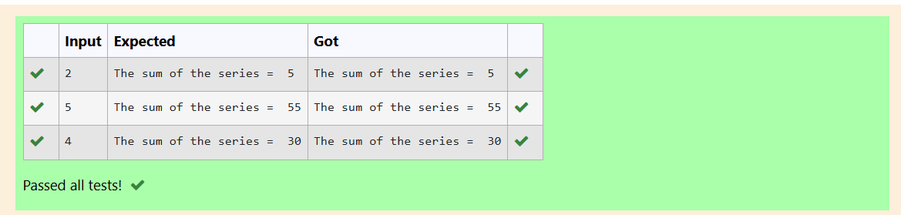

2. Python Program to check if a number is a Perfect number using the concept of [functions](http://training.saveetha.in/mod/hvp/view.php?id=3171).

**For example:**

| **Input** | **Result** |
| --- | --- |
| 6 | The number is a Perfect number! |

PROGRAM:

a=int(input())

sum=0

for i in range (1,a):

if(a%i==0):

sum=sum+i

if sum==a:

print("The number is a Perfect number!")

else:

print("The number is not a Perfect number!")

RESULT:

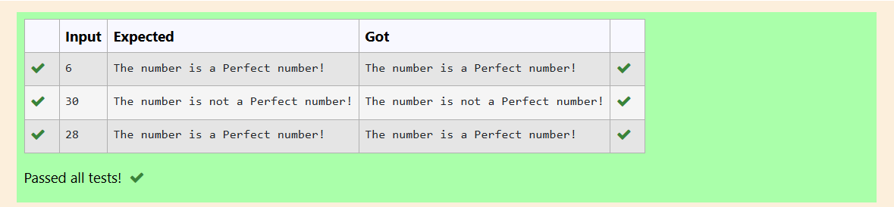

3. Write a function which takes three arguments: a and b and c and returns the multiplication  of them: a*b*c. Assign it to a variable named: f. using python

**For example:**

| **Input** | **Result** |
| --- | --- |
| 10  20  30 | 6000 |

PROGRAM:

a=int(input())

b=int(input())

c=int(input())

f=lambda a,b,c:a*b*c

print(f(a,b,c))

RESULT:

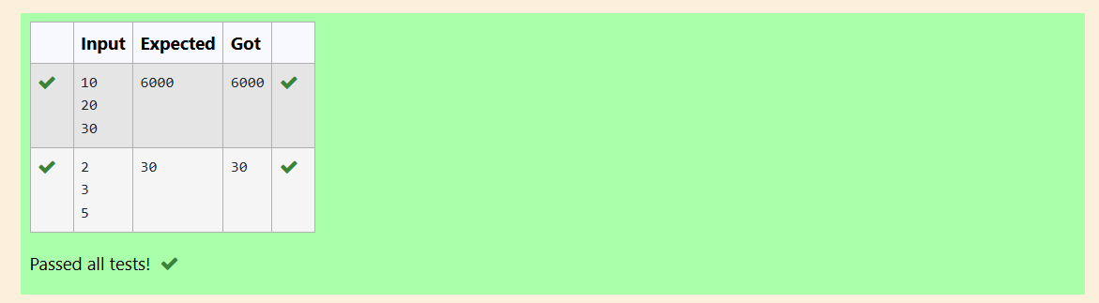

4. Python program to print alternate number pattern .Get the number of rows as input

**For example:**

| **Input** | **Result** |
| --- | --- |
| 5 | 1  3 3  5 5 5  7 7 7 7  9 9 9 9 9 |

PROGRAM:

a=int(input())

for i in range(1,a+1):

b=2*i-1

for j in range(1,i+1):

print(b,end=" ")

print()

RESULT:

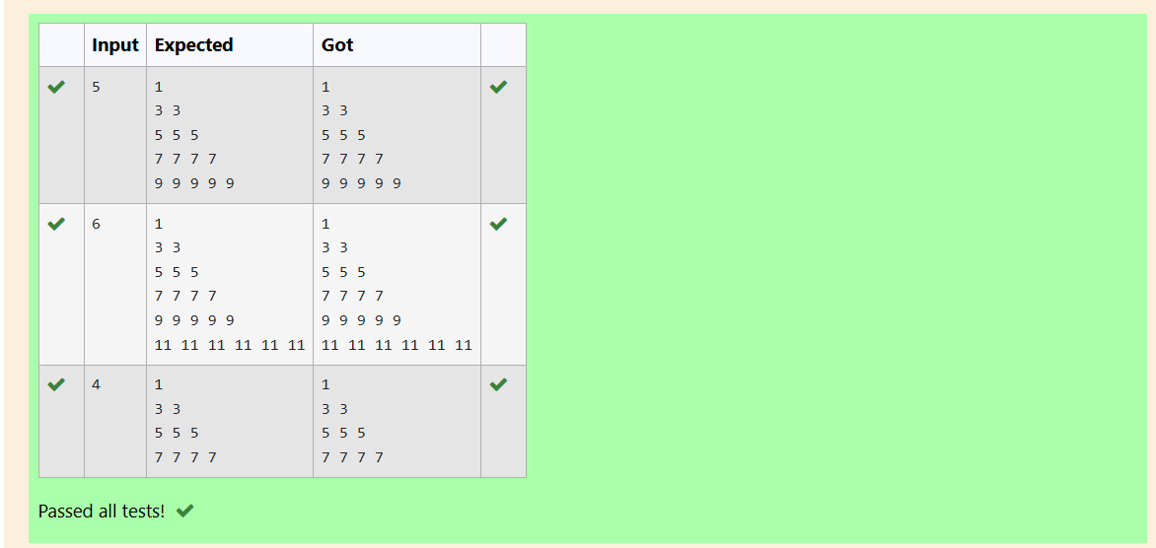

5. Write Python program to print reverse Pyramid of numbers.Get the number of rows as input.

**For example:**

| **Input** | **Result** |
| --- | --- |
| 6 | 1  2 1  3 2 1  4 3 2 1  5 4 3 2 1 |

PROGRAM:

a=int(input())

for i in range(1,a):

for j in range(i,0,-1):

print(j,end=" ")

print()

RESULT:

